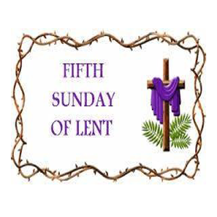
Our Mission:
"To spread the Good News of Jesus Christ, and promote spiritual growth through
worship, study, witness and service."

March 17, 2024

Service book

@ https://www.youtube.com/@SaintLukesWhalleyAve
Church’s Corner
Welcome To St. Luke's Episcopal Church! --We are pleased that you have chosen to worship with us. During the continuing COVID-19 pandemic some of us are still not physically present in this sacred space. Because of this we continue saying a prayer to reflect our spiritual sharing of the bread and wine. Some of this service will be read by a member of the St. Luke’s Lectors Guild.

Today’s worship team 10 a.m.:  Sheila Martin-Corbin, Lector  Samuel Andoh, Eucharistic Minister  Nathan ELSBERND, Organist & Director of Music  The Rev. Kathryn Greene-McCreight, Presider & Preacher | 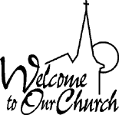  Visitors are warmly welcomed to join us online for meetings and worship. Worship books may be downloaded from our web site stlukeschurchnewhaven.com  In our prayers this week, we pray for, All Saints’, Ivoryton; St. Andrew’s, Kent; Emmanuel, Killingworth; Trinity, Lime Rock.  In Our Diocese, we pray for, Bishops, ECCT staff, and parish employees, and their families.  In the Anglican Cycle of Prayer, we pray for, the Church in Wales.  Stewardship Appeal: Please send in your weekly and monthly contributions to St. Luke’s by mail or thru the Online portal. You may also ask your bank or credit union to set up a monthly payment to St. Luke’s through their “Bill Pay” features.  Monthly Stewardship Report  Income for January 2024  $18,336.86  Expenses for January 2024  $16,264.51  The next Vestry will hold their next monthly online meeting, on Tuesday, March 26th at 6 p.m. on zoom. Most of the meeting is open to members and friends of the parish. Please contact the church office if you would like to join the meeting. Thank you.
READINGS FOR NEXT SUNDAY
Palm Sunday
Sunday of the Passion

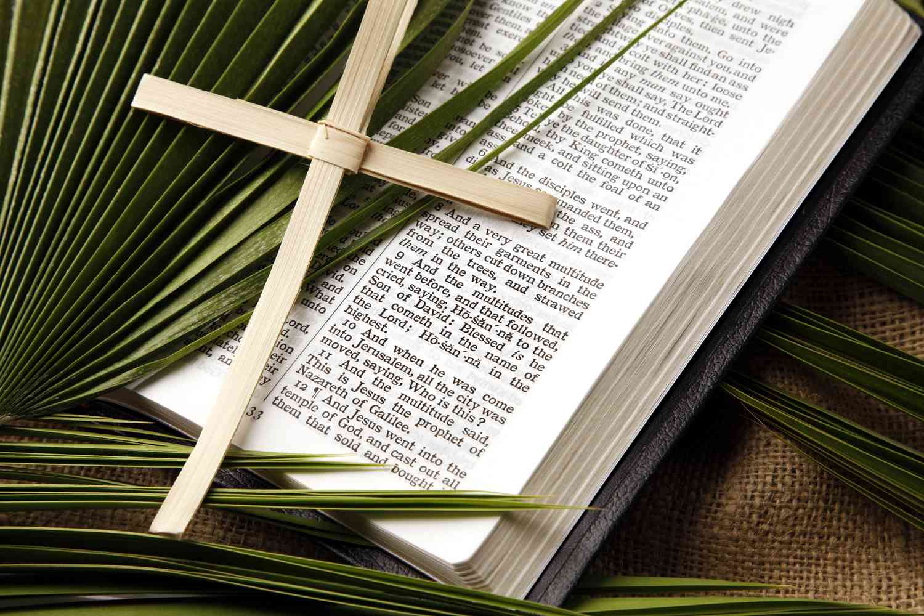
The First Lesson
Isaiah 50:4-9a
The Psalm
Psalm 31:9-16
The Epistle
Philippians 2:5-11
The Gospel
Mark 14:1—1547 or 15:1-39 (40-47)

Holy Eucharist
Fifth Sunday in Lent Sunday, March 17, 2024

Prelude

Entrance Rite
At the sound of the bell, all stand for the Entrance of the Ministers into the church.
The Opening Hymn I Will Arise AAHH 361
Presider Bless the Lord who forgiveth all our sins.
People His mercy endureth forever.

Decalogue
The people kneel.
God spake these words, and said: I am the Lord thy God who brought thee out of the land of Egypt, out of the house of bondage. Thou shalt have none other gods but me.
Lord, have mercy upon us,
and incline our hearts to keep this law.
Thou shalt not make to thyself any graven image, nor the likeness of anything that is in heaven above, or in the earth beneath, or in the water under the earth; thou shalt not bow down to them, nor worship them.
Lord, have mercy upon us,
and incline our hearts to keep this law.
Thou shalt not take the Name of the Lord thy God in vain.
Lord, have mercy upon us,
and incline our hearts to keep this law.
Remember that thou keep holy the Sabbath day.
Lord, have mercy upon us,
and incline our hearts to keep this law.
Honor thy father and thy mother.
Lord, have mercy upon us,
and incline our hearts to keep this law.
Thou shalt do no murder.
Lord, have mercy upon us,
and incline our hearts to keep this law.
Thou shalt not commit adultery.
Lord, have mercy upon us,
and incline our hearts to keep this law.
Thou shalt not steal.
Lord, have mercy upon us,
and incline our hearts to keep this law.
Thou shalt not bear false witness against thy neighbor.
Lord, have mercy upon us,
and incline our hearts to keep this law.
Thou shalt not covet.
Lord, have mercy upon us,
and write all these thy laws in our hearts, we beseech thee.
The Presider says:
Seeing that we have a great high priest, that is passed into the heavens, Jesus the Son of God, let us come boldly unto the throne of grace, that we may obtain mercy, and find grace to help in time of need. Hebrews 4:14, 16

The following is said, all standing
Kyrie Spoken
Lord, have mercy upon us.
Christ, have mercy upon us.
Lord, have mercy upon us.

Liturgy of the Word

Collect of the Day
Presider: The Lord be with you.
People: And also with you.
Presider: Let us pray.

Almighty God, you alone can bring into order the unruly wills and affections of sinners: Grant your people grace to love what you command and desire what you promise; that, among the swift and varied changes of the world, our hearts may surely there be fixed where true joys are to be found; through Jesus Christ our Lord, who lives and reigns with you and the Holy Spirit, one God, now and forever. Amen.
First Reading Jeremiah 31:31-34
Please be seated.
A Reading from the book of Jeremiah
The days are surely coming, says the Lord, when I will make a new covenant with the house of Israel and the house of Judah. It will not be like the covenant that I made with their ancestors when I took them by the hand to bring them out of the land of Egypt—a covenant that they broke, though I was their husband, says the Lord. But this is the covenant that I will make with the house of Israel after those days, says the Lord: I will put my law within them, and I will write it on their hearts; and I will be their God, and they shall be my people. No longer shall they teach one another, or say to each other, “Know the Lord,” for they shall all know me, from the least of them to the greatest, says the Lord; for I will forgive their iniquity, and remember their sin no more.

Reader: The Word of the Lord.
People: Thanks be to God.

Psalm 51:1-13
Miserere mei, Deus
1 Have mercy on me, O God, according to your loving-kindness; in your great compassion blot out my offenses.
2 Wash me through and through from my wickedness and cleanse me from my sin.
3 For I know my transgressions, and my sin is ever before me.
4 Against you only have I sinned and done what is evil in your sight.
5 And so you are justified when you speak and upright in your judgment.
6 Indeed, I have been wicked from my birth, a sinner from my mother's womb.
7 For behold, you look for truth deep within me, and will make me understand wisdom secretly.
8 Purge me from my sin, and I shall be pure; wash me, and I shall be clean indeed.
9 Make me hear of joy and gladness, that the body you have broken may rejoice.
10 Hide your face from my sins and blot out all my iniquities.
11 Create in me a clean heart, O God, and renew a right spirit within me.
12 Cast me not away from your presence and take not your Holy Spirit from me.
13 Give me the joy of your saving help again and sustain me with your bountiful Spirit.

Glory be to the Father, and to the Son: and to the Holy Spirit; as it was in the beginning, is now, and will be forever. Amen.

Second Reading Hebrews 5:5-10
A Reading from the book of Hebrews
Christ did not glorify himself in becoming a high priest, but was appointed by the one who said to him,
“You are my Son, today I have begotten you”;
as he says also in another place,
“You are a priest forever, according to the order of Melchizedek.”
In the days of his flesh, Jesus offered up prayers and supplications, with loud cries and tears, to the one who was able to save him from death, and he was heard because of his reverent submission. Although he was a Son, he learned obedience through what he suffered; and having been made perfect, he became the source of eternal salvation for all who obey him, having been designated by God a high priest according to the order of Melchizedek.

Reader : The Word of the Lord.
People: Thanks be to God.

Gradual Hymn Kind Maker of the World (vv1-4) H 152
Please stand as you are able.

Holy Gospel John 12:20-33
Presider: The Holy Gospel of our Lord Jesus Christ according to John
People: Glory to you, Lord Christ.
Now among those who went up to worship at the festival were some Greeks. They came to Philip, who was from Bethsaida in Galilee, and said to him, “Sir, we wish to see Jesus.” Philip went and told Andrew; then Andrew and Philip went and told Jesus. Jesus answered them, “The hour has come for the Son of Man to be glorified. Very truly, I tell you, unless a grain of wheat falls into the earth and dies, it remains just a single grain; but if it dies, it bears much fruit. Those who love their life lose it, and those who hate their life in this world will keep it for eternal life. Whoever serves me must follow me, and where I am, there will my servant be also. Whoever serves me, the Father will honor.
“Now my soul is troubled. And what should I say—‘Father, save me from this hour’? No, it is for this reason that I have come to this hour. Father, glorify your name.” Then a voice came from heaven, “I have glorified it, and I will glorify it again.” The crowd standing there heard it and said that it was thunder. Others said, “An angel has spoken to him.” Jesus answered, “This voice has come for your sake, not for mine. Now is the judgment of this world; now the ruler of this world will be driven out. And I, when I am lifted up from the earth, will draw all people to myself.” He said this to indicate the kind of death he was to die.

Presider: The Gospel of the Lord.
People: Praise to you, Lord Christ.
Gradual Hymn Kind Maker of the World (v 5) H 152
Sermon Rev. Kathryn Greene-McCrieght
Reflection Hymn Where He Leads Me H 550

Nicene Creed BCP 326
Please join as we say this rational affirmation of our faith.
We believe in one God,
the Father, the Almighty,
maker of heaven and earth,
of all that is, seen and unseen.
We believe in one Lord, Jesus Christ,
the only Son of God,
eternally begotten of the Father,
God from God, Light from Light,
true God from true God,
begotten, not made,
of one Being with the Father.
Through him all things were made.
For us and for our salvation
he came down from heaven:
by the power of the Holy Spirit
he became incarnate from the Virgin Mary,
and was made man.
For our sake he was crucified under Pontius Pilate;
he suffered death and was buried.
On the third day he rose again
in accordance with the Scriptures;
he ascended into heaven
and is seated at the right hand of the Father.
He will come again in glory to judge the living and the dead,
and his kingdom will have no end.
We believe in the Holy Spirit, the Lord, the giver of life,
who proceeds from the Father and the Son.
With the Father and the Son he is worshiped and glorified.
He has spoken through the Prophets.
We believe in one holy catholic and apostolic Church.
We acknowledge one baptism for the forgiveness of sins.
We look for the resurrection of the dead,
and the life of the world to come. Amen.

Prayers of the People BCP 328
Please remain standing as you are able.
Let us pray for the whole state of Christ’s Church and the world.
After each paragraph of this prayer, the People may make an appropriate response, as directed.
Almighty and everliving God, who in thy holy Word hast taught us to make prayers, and supplications, and to give thanks for all men: Receive these our prayers which we offer unto thy divine Majesty, beseeching thee to inspire continually the Universal Church with the spirit of truth, unity, and concord; and grant that all those who do confess thy holy Name may agree in the truth of thy holy Word, and live in unity and godly love.
Give grace, O heavenly Father, to all bishops and other ministers especially Michael our Presiding bishop, Jeff and Laura our bishops, and Teresa our priest, that they may, both by their life and doctrine, set forth thy true and lively Word, and rightly and duly administer thy holy Sacraments.
And to all thy people give thy heavenly grace, and especially to this congregation here present; that, with meek heart and due reverence, they may hear and receive thy holy Word, truly serving thee in holiness and righteousness all the days of their life.
We beseech thee also so to rule the hearts of those who bear the authority of government in this and every land that they may be led to wise decisions and right actions for the welfare and peace of the world.
Open, O Lord, the eyes of all people to behold thy gracious hand in all thy works, that, rejoicing in thy whole creation, they may honor thee with their substance, and be faithful stewards of thy bounty.
And we most humbly beseech thee, of thy goodness, O Lord, to comfort and succor all those who, in this transitory life, are in trouble, sorrow, need, sickness, or any other adversity.
Additional petitions and thanksgivings may be included here.
And we also bless thy holy Name for all thy servants departed this life in thy faith and fear, beseeching thee to grant them continual growth in thy love and service; and to grant us grace so to follow the good examples of Blessed Luke and of all thy saints, that with them we may be partakers of thy heavenly kingdom.
Grant these our prayers, O Father, for Jesus Christ’s sake, our only Mediator and Advocate. Amen.
O God, whose glory it is always to have mercy: Be gracious to all who have gone astray from thy ways, and bring them again with penitent hearts and steadfast faith to embrace and hold fast the unchangeable truth of thy Word, Jesus Christ thy Son; who with thee and the Holy Spirit liveth and reigneth, one God, for ever and ever. Amen.
The Presider:
Ye who so truly and earnestly repent you of your sins, and are in love and charity with your neighbors, and intend to lead a new life following the commandments of God, and walking from henceforth in his holy ways: Draw near with faith, and make your humble confession to Almighty God devoutly kneeling.

Let us humbly confess our sins unto Almighty God
A period of silence is observed.
Minister and People together say:
Confession of Sins BCP 331
Almighty God, Father of our Lord Jesus Christ, Maker of all
things, judge of all men: We acknowledge and bewail our manifold sins
and wickedness, which we from time to time most grievously have committed,
by thought, word, and deed, against thy divine Majesty, provoking
most justly thy wrath and indignation against us.
We do earnestly repent, and are heartily sorry for these our misdoings:
The remembrance of them is grievous unto us, the burden of them is intolerable.
Have mercy upon us, have mercy upon us, most merciful Father;
For thy Son our Lord Jesus Christ’s sake forgive us all that is past;
and grant that we may ever hereafter serve and please thee in newness of life to the honor and glory of thy Name; through Jesus Christ our Lord, Amen

The Priest stands and says:
The Almighty and merciful Lord grant you absolution and remission of all your sins, true repentance, amendment of life, and the grace and consolation of his Holy Spirit. Amen.

Prayers for St. Luke’s Church Family
Please stand as you are able as the Presider leads prayers for our church family.
Prayers for Birthdays
Mar 17th Lloyd Daniel
19th Sharon Bradford-Henderson
21st Joshua A. Carroll Anthony Murrell
22nd Donna Johnson

Presider: Let us join in praying together for those having birthdays this week this prayer from the Book of Common Prayer.
People & Presider: O God, our times are in your hand: Look with favor, we pray, on your servants, as they begin another year. Grant that they may grow in wisdom and grace, and strengthen their trust in your goodness all the days of their life; through Jesus Christ our Lord. Amen.
St. Luke’s Prayers List
We pray by first name for those on our prayer list:
Genevieve Jones, Rose Jones, Craig Lindsey, Brenda Smith, Dorothy Smith, Evelyn Singley, Gloria Brown, Carol Williams-Davis, Patricia Harris, Connie Mills, Ula Robertson, John & Leslie White, Gloria Williams, Phyllis Lindsey, June Davis, Valerie Jackson-Pittman and her daughter Andrea, Sheila Martin-Corbin, Clarence Philip, Eileen Esdaile, Shaina Stanley, Ed & Suzy Burke, Laurence Downes, Anabel Smith, Amy Wormley, Cecilia Parchment, Jennifer Gorley, The Obi Family, Dorothea Howard, Beverly Huckaby, Jackye Haywood, Joy DeYounge, Mae Huckaby, Sally Steadwell, Rev. Darryl James, Lenore Standard, Laura Richling, Tracy Telford, Rev. Cathi Bencken, Jeffery Stanley, William ‘Bill’ Spruill, Dorreth Cole, Carolyn Rhinehart, Pat Whitney and Loreen Nisbett.
Let us pray that they may be comforted by our prayers and God’s blessing. May the Church say Amen! Amen!

The Peace

The peace of the Lord be always with you

People: And also with you.

Welcoming of Visitors: Senior Warden, Valarie Stanley

Announcements
The Network Guild will have its monthly meeting today, March 17th immediately after the service in the Parish Hall. Sharon Andoh has a presentation which will run for 16 minutes prior to the meeting. We would appreciate it, if both can be conducted in a timely manner. Thank you.

Melanese Kotey, St. Luke’s Network Guild President

Holy Communion
The Presider says:

If you are offering your gift at the altar, and there remember that your brother has something against you, leave your gift there before the altar and go; first be reconciled to your brother, and then come and offer your gift. Matthew 5:23, 24

Offertory Anthem Somebody’s Knockin’ at your Door Michael Larkin

Doxology We sing only the last verse H 380
As we sing the last verse of the Doxology, the People's offerings are presented. As a sign that along with the gifts we are made to assist in God's work, the People and Presider are censed. The People and Thurifer acknowledge each other with a bow before and after the censing.
Offertory Hymn I’ll Be Somewhere Listening for my Name AAHH 560

Great Thanksgiving Eucharistic Prayer I BCP 333
The people remain standing.
Presider: The Lord be with you.
People: And with thy spirit.
Presider: Lift up your hearts.
People: We lift them up unto the Lord.
Presider: Let us give thanks unto our Lord God.
People: It is meet and right so to do.
The Presider proceeds
It is very meet, right, and our bounden duty, that we should at all times, and in all places, give thanks unto thee, O Lord, holy Father, almighty, everlasting God.
Through Jesus Christ our Lord, who was in every way tempted as we are, yet did not sin; by whose grace we are able to triumph over every evil, and to live no longer unto ourselves, but unto him who died for us and rose again.
Therefore with Angels and Archangels, and with all the company of heaven, we laud and magnify thy glorious Name; evermore praising thee, and saying,

Sanctus BCP 334 (Spoken)
Presider and People
Holy, holy, holy, Lord God of Hosts:
Heaven and earth are full of thy glory.
Glory be to thee, O Lord Most High.
Blessed is he that cometh in the name of the Lord.
Hosanna in the highest.
The people stand or kneel. The Presider continues
All glory be to thee, O Lord our God, for that thou didst create heaven and earth, and didst make us in thine own image; and, of thy tender mercy, didst give thine only Son Jesus Christ to take our nature upon him, and to suffer death upon the cross for our redemption. He made there a full and perfect sacrifice for the whole world; and did institute, and in his holy Gospel command us to continue, a perpetual memory of that his precious death and sacrifice, until his coming again.
For in the night in which he was betrayed, he took bread; and when he had given thanks to thee, he broke it, and gave it to his disciples, saying, “Take, eat, this is my Body, which is given for you. Do this in remembrance of me.”
Likewise, after supper, he took the cup; and when he had given thanks, he gave it to them, saying, “Drink this, all of you; for this is my Blood of the New Covenant, which is shed for you, and for many, for the remission of sins. Do this, as oft as ye shall drink it, in remembrance of me.”
Wherefore, O Lord and heavenly Father, we thy people do celebrate and make, with these thy holy gifts which we now offer unto thee, the memorial thy Son hath commanded us to make; having in remembrance his blessed passion and precious death, his mighty resurrection and glorious ascension; and looking for his coming again with power and great glory.
And we most humbly beseech thee, O merciful Father, to hear us, and, with thy Word and Holy Spirit, to bless and sanctify these gifts of bread and wine, that they may be unto us the Body and Blood of thy dearly-beloved Son Jesus Christ.
And we earnestly desire thy fatherly goodness to accept this our sacrifice of praise and thanksgiving, whereby we offer and present unto thee, O Lord, ourselves, our souls and bodies. Grant, we beseech thee, that all who partake of this Holy Communion may worthily receive the most precious Body and Blood of thy Son Jesus Christ, and be filled with thy grace and heavenly benediction; and also that we and all thy whole Church may be made one body with him, that he may dwell in us, and we in him; through the same Jesus Christ our Lord;
By whom, and with whom, and in whom, in the unity of the Holy Ghost all honor and glory be unto thee, O Father Almighty, world without end. AMEN.
The Presider then continues
And now, as our Savior Christ hath taught us, we are bold to say,
People and Presider
The Presider then continues:
The Lord’s Prayer BCP 336 (Spoken)
Our Father in heaven,
hallowed be your Name,
your kingdom come,
your will be done,
on earth as in heaven.
Give us today our daily bread.
Forgive us our sins
as we forgive those
who sin against us.
Save us from the time of trial,
and deliver us from evil.
For the kingdom, the power,
and the glory are yours,

now and forever. Amen

Breaking of the Bread
A period of silence is kept.
Fraction Anthem BCP 337(Spoken)
Christ our Passover is sacrificed for us;
Therefore let us keep the feast.
O Lamb of God, that takest away the sins of the world,
have mercy on us.
O Lamb of God, that takest away the sins of the world,
have mercy on us.
O Lamb of God, that takest away the sins of the world,
grant us thy peace.

We do not presume to come to this thy Table, O merciful Lord, trusting in our own righteousness, but in thy manifold and great mercies. We are not worthy so much as to gather up the crumbs under thy Table. But thou art the same Lord whose property is always to have mercy. Grant us therefore, gracious Lord, so to eat the flesh of thy dear Son Jesus Christ, and to drink his blood, that we may evermore dwell in him, and he in us. Amen.
The Presider says:
The Gifts of God for the People of God. Take them in remembrance that Christ died for you, and feed on him in your hearts by faith, with thanksgiving.
People: Lord, I am not worthy that you shouldst come under my roof, but speak the word only and my soul shall be healed.
A period of silence is kept.

Communion Hymns

Let thy Blood in mercy poured H 313
Calvary AAHH 239

Postcommunion Prayer BCP 339
After Communion, the Presider says:
Let us pray.
Presider and People:
Celebrant and People
Almighty and everliving God, we most heartily thank thee for that thou dost feed us, in these holy mysteries, with the spiritual food of the most precious Body and Blood of thy Son our Savior Jesus Christ; and dost assure us thereby of thy favor and goodness towards us; and that we are very members incorporate in the mystical body of thy Son, the blessed company of all faithful people; and are also heirs, through hope, of thy everlasting kingdom. And we humbly beseech thee, O heavenly Father, so to assist us with thy grace, that we may continue in that holy fellowship, and do all such good works as thou hast prepared for us to walk in; through Jesus Christ our Lord, to whom, with thee and the Holy Ghost, be all honor and glory, world without end. Amen.

The Blessing
The priest blesses the people:
Recessional Hymn I Want Jesus to Walk with Me LEVAS 70

Dismissal

Presider Let us go forth in the name of Christ.

People Thanks be to God.
Postlude:

The Vestry & Staff of St Luke’s Episcopal Church
Valarie Stanley, Senior Warden ▪ Bryant Grimes, Junior Warden
Everson Smith, Treasurer ▪ Lisa W. Yarbor, Parish Clerk
Elnora Carroll, Danisha Collins, George DeYounge, Eileen Esdaile, Jocelyn Freeman,
Darryl Huckaby, Donna Johnson

The Episcopal Church in Connecticut (ECCT)
The Rt. Rev. Jeffrey W. Mello, Bishop Diocesan
The Rt. Rev. Laura Ahrens, Bishop Suffragan
St. Luke’s Episcopal Church, New Haven
The Rev. Victor Rogers, Rector Emeritus
Georgia Wilson-Service, Parish Administrator
Nathan Elsbernd, Organist/Director of Music

